Dridex Traffic Analysis
Introduction: Dridex is a long-running banking trojan that first appeared around 2011, primarily spread through malicious email attachments and macros. It is significant because it evolved from simple credential theft into a modular malware platform capable of delivering ransomware and other payloads, often used by organized cybercriminal groups. Understanding its network traffic, especially encrypted C2 communications, helps defenders develop detection strategies that remain effective even when attackers attempt to hide behind TLS encryption.
Objective: Analyze actual Dridex traffic from Palo Alto Unit42 PCAP dataset.
Tools used: Wireshark, Suricata, MITRE ATT&CK framework.
Focus areas:
- Identify malicious TLS/SSL traffic patterns.
- Examine suspicious certificates and handshake behavior.
- Write detection rules that do not rely on payload decryption.
- Map observations to adversary TTPs.
Dataset: Palo Alto Unit42 Dridex PCAPs (https://github.com/pan-unit42/wireshark-tutorial-Dridex-traffic)
Methodology:
Wireshark Setup:
- Built initial customized layout for enhanced HTTP traffic analysis then further tuned it for TLS analysis, adding columns for metadata such as Sever Name Indication (SNI), JA3 fingerprints, and TLS version. (Certificate details such as Subject CN and Issuer were inspected manually as opposed to adding these fields to the configuration, since my build does not expose per-RDN fields as clean column options.)
Filtering strategy:
- To isolate Dridex infection and post-infection C2 traffic, I built progressive display filters that targeted TLS handshake anomalies, certificate metadata, and JA3 fingerprints. Rather than simply pivoting on IPs, the focus was on protocol behaviors more indicative of malicious activity. See Table 1.
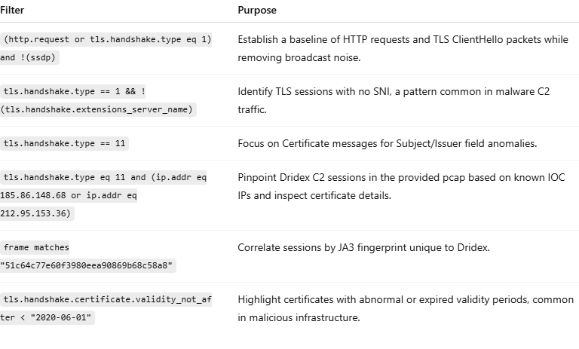Table 1: Wireshark display filters applied during analysis.
Timeline and Flow of Infection:
Initial Contact/Loader Download
- Client reaches truepenesonga[.]com
- Let’s Encrypt CA is not malicious on its own, but domain is known malicious.
- The post-handshake bulk TLS application data is consistent with a staged payload download (Dridex loader); when correlated with the malicious domain and JA3 fingerprint, this exchange marks the start of the infection chain.

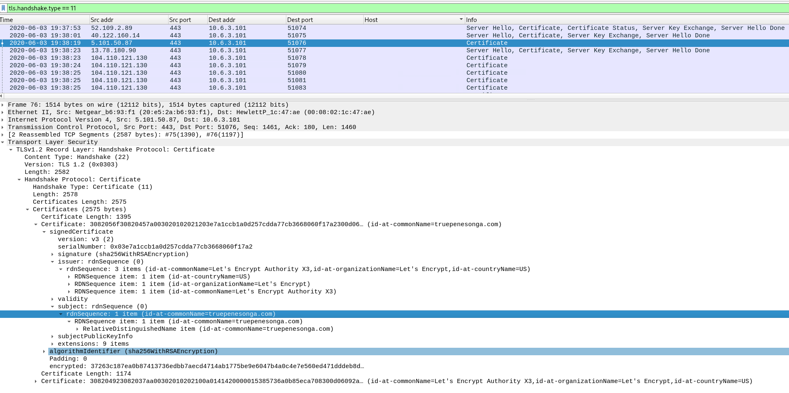
Figure 1: TLS handshake to truepenesonga[.]com showing certificate chain issued by Let’s Encrypt Authority X3. The presence of a legitimate CA does not imply trust — this domain is confirmed malicious and served as the Dridex loader distribution host.
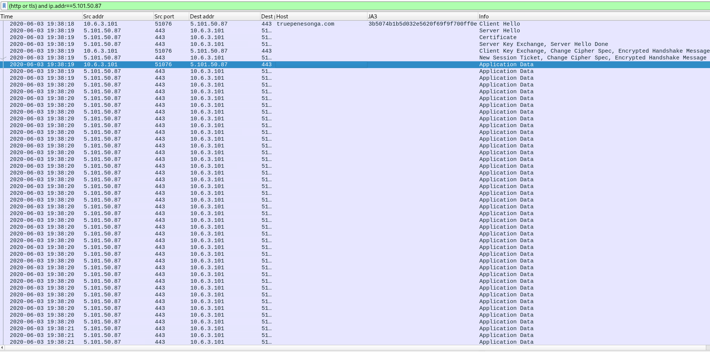
Figure 2: Encrypted TLS Application Data exchange between the victim host and truepenesonga[.]com immediately following the handshake. This traffic likely represents the download of the Dridex loader payload from the malicious domain over HTTPS, concealed within legitimate-appearing encrypted communication.

Post-Infection Command-and Control (C2) Activity
- Following execution of the loader, the infected host initiates new TLS sessions to two raw IP addresses (185.86.148[.]68, 212.95.153[.]36) with no associated domain names.
- These sessions exhibit a distinct JA3 fingerprint (51c64c77e60f3980eea90869b68c58a8) compared to the loader’s (3b5074b1b5d032e5620f69f9f700ff0e), indicating a process transition—likely from the downloader to the Dridex payload—and the use of a different TLS stack.
- The presented X.509 certificates contain randomized alphanumeric subject and issuer fields and lack Subject Alternative Name (SAN) entries, consistent with auto-generated or self-signed certificates frequently observed in malware C2 infrastructure.
- Although the encrypted payload prevents direct validation of the exchanged content, the timing, JA3 shift, and anomalous TLS characteristics strongly suggest these sessions represent Dridex post-compromise C2 or stage-retrieval activity.

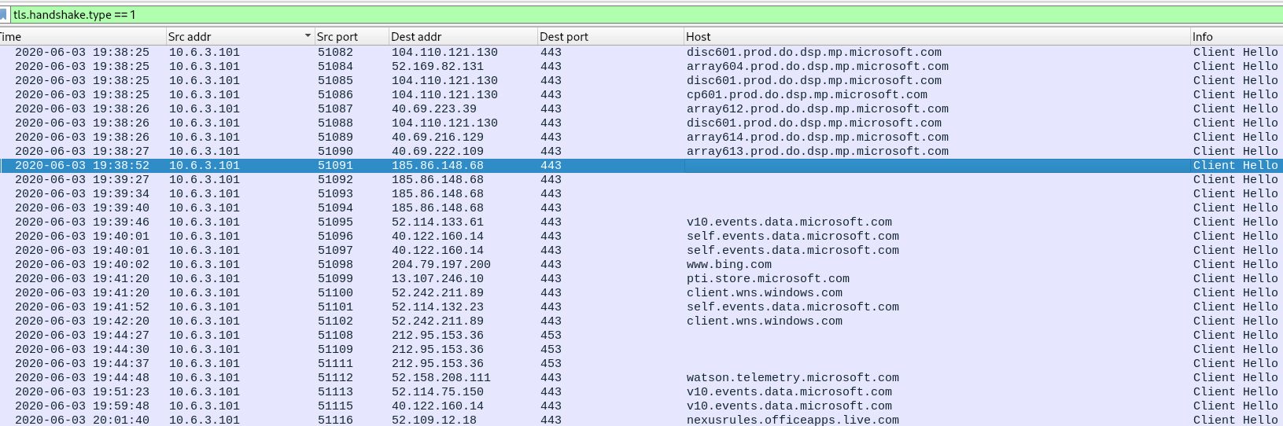
Figure 3: Overview of TLS ClientHello packets observed immediately after the loader stage. The host begins new TLS sessions to raw IP addresses (185.86.148[.]68, 212.95.153[.]36) alongside normal Microsoft telemetry traffic. These bare-IP handshakes mark the pivot from the benign loader phase toward the suspected Dridex C2 communication, examined in subsequent figures that highlight the absence of SNI and certificate irregularities.

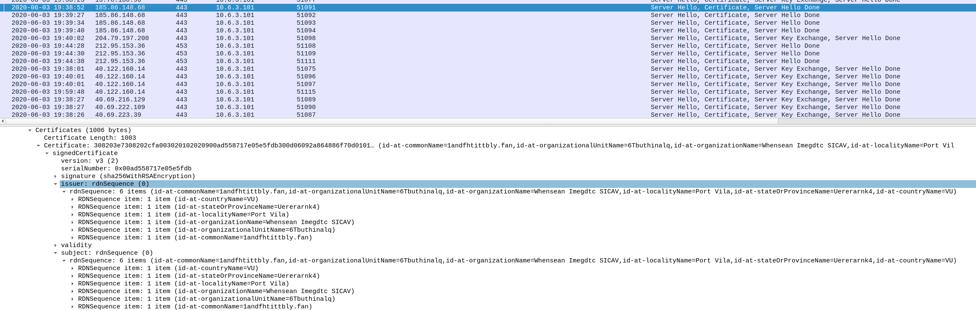
Figure 4: TLS ServerHello and Certificate exchange for the C2 IP (185.86.148[.]68). The session contains no Server Name Indication (SNI) value and presents an X.509 certificate with no Subject Alternative Name (SAN) and randomized issuer/subject fields (e.g., “landfhtbtly.fan,” “GTbuthinlq”). These anomalies—combined with direct IP communication and the timing of the session—are strong indicators of auto-generated or self-signed certificates commonly used in Dridex C2 infrastructure. Similar characteristics were observed for the second C2 IP (212.95.153[.]36).

Behavioral Indicators and Traffic Characteristics
- Bulk Transfer Behavior
  - TLS Application Data bursts (~16 KB) segmented across ~40 packets within 3 seconds suggest a large stage or payload download rather than interactive beaconing.
  - A second burst from 212.95.153[.]36 follows immediately, likely retrieving a secondary module.
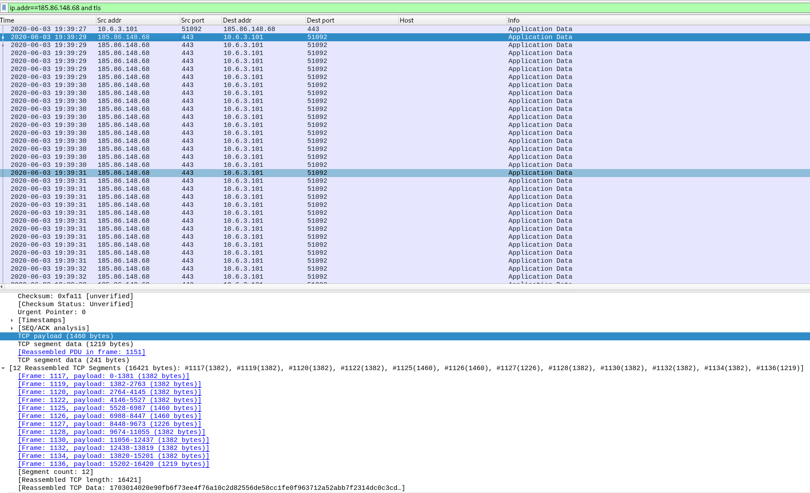
Figure 5: TLS Application Data burst from 185.86.148.68.

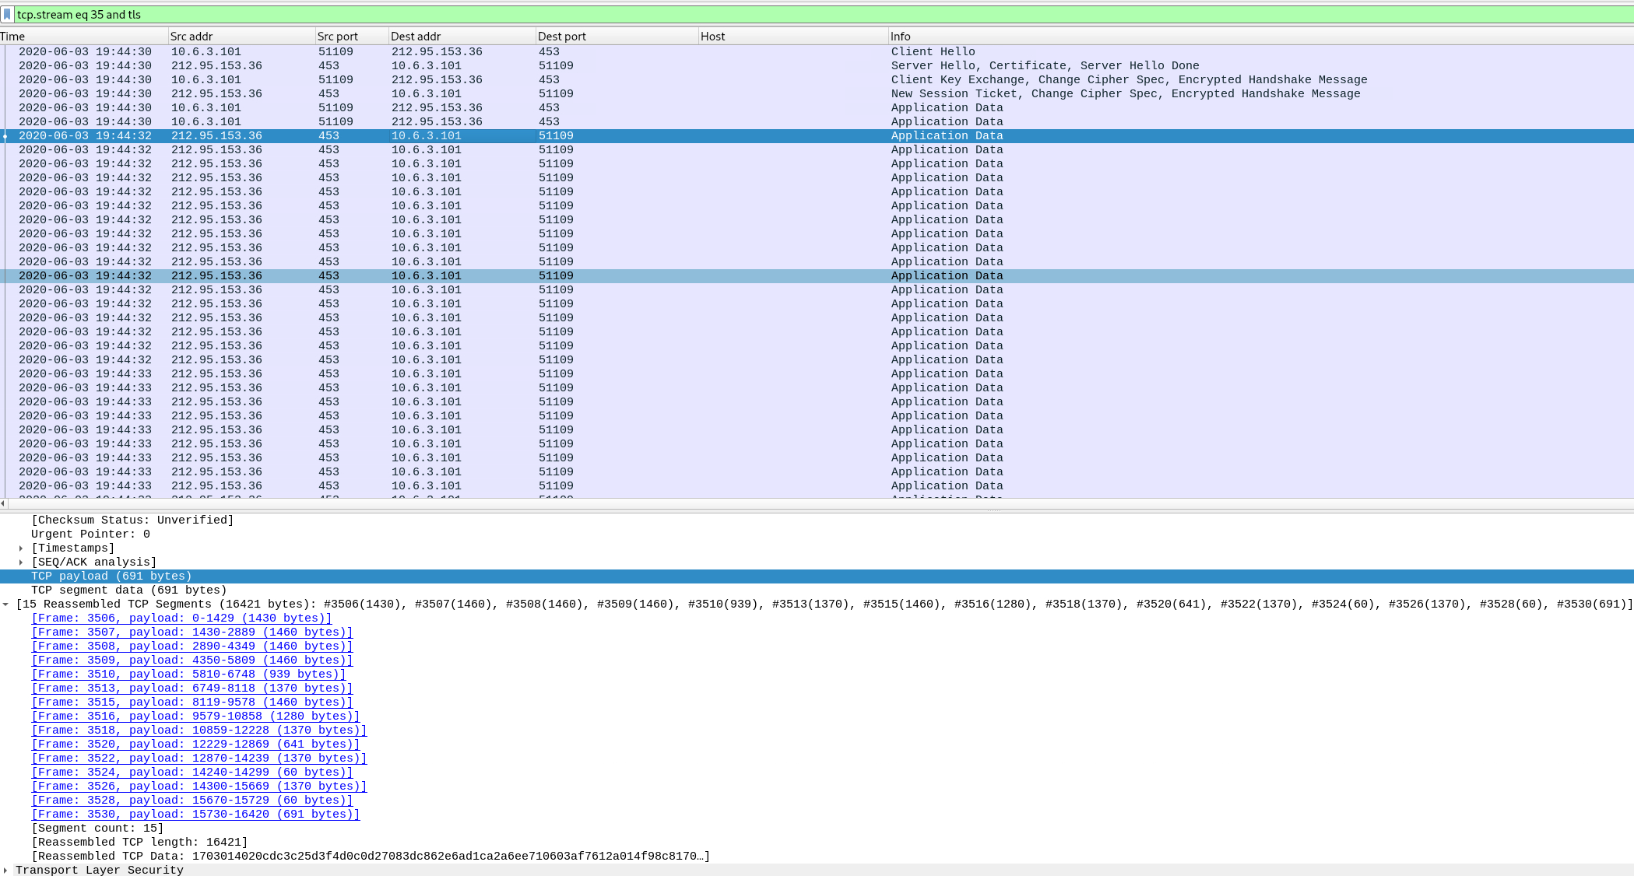
Figure 6: Subsequent burst from 212.95.153.36.

JA3 Fingerprint Analysis

During analysis of the Dridex infection traffic, TLS ClientHello messages were inspected to extract JA3 fingerprints—hashes derived from TLS parameters (cipher suites, extensions, elliptic curves, etc.) that uniquely characterize a client’s TLS implementation.
While JA3 values are not inherently malicious, they provide consistent identifiers for TLS stacks often reused by specific malware families.
- Observed Values:
  - 3b5074b1b5d032e5620f69f9f700ff0e – Observed in TLS connections to truepenesonga[.]com. According to open-source threat intelligence, including entries on AlienVault OTX and Netresec’s malware TLS research, this JA3 has previously been linked to Dridex downloaders and similar malware families
  - 51c64c77e60f3980eea90869b68c58a8 – Observed consistently in subsequent TLS sessions to the C2 IPs 185.86.148[.]68 and 212.95.153[.]36.
    - These sessions contained no Server Name Indication (SNI) and used bare IP addresses, consistent with malware-internal TLS communications.
    - The fingerprint remained identical across both C2 endpoints, suggesting reuse of the same embedded TLS library by the Dridex payload.
- Interpretation:
  - The host initially contacted truepenesonga[.]com using JA3 3b5074b1b5d032e5620f69f9f700ff0e (Figure 5). Immediately afterward, it initiated bare-IP TLS sessions to 185.86.148[.]68 and 212.95.153[.]36 using JA3 51c64c77e60f3980eea90869b68c58a8 (Figures 6–7).
  - The consistent reuse of the second JA3 across multiple C2 IPs reinforces attribution, as legitimate applications rarely change TLS stacks mid-session sequence.
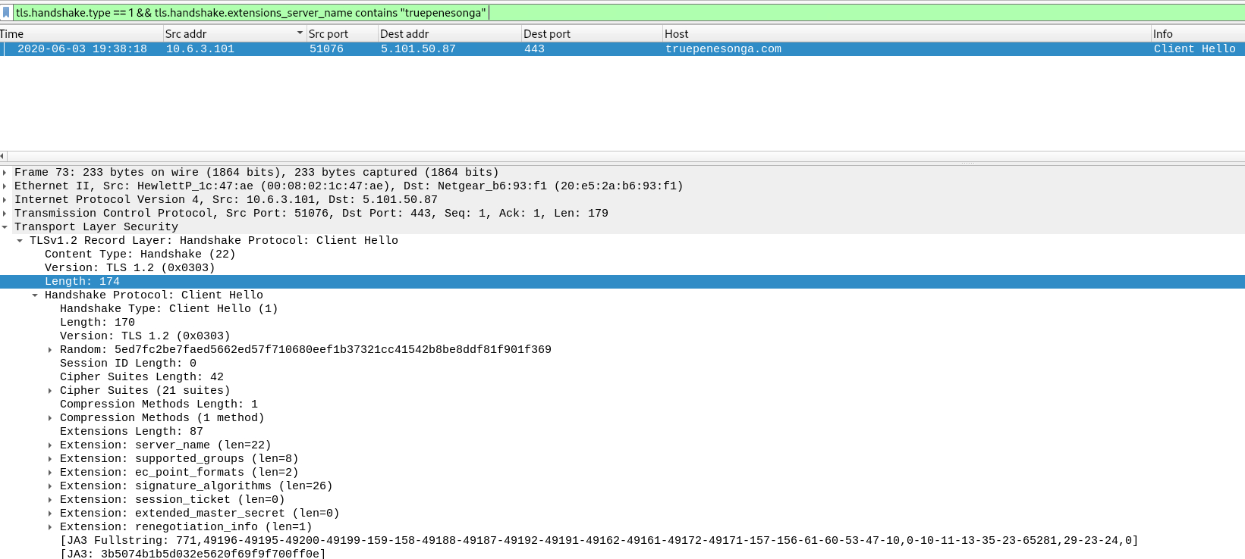
Figure 7: ClientHello to truepenesonga[.]com showing JA3 3b5074b1b5d032e5620f69f9f700ff0e.
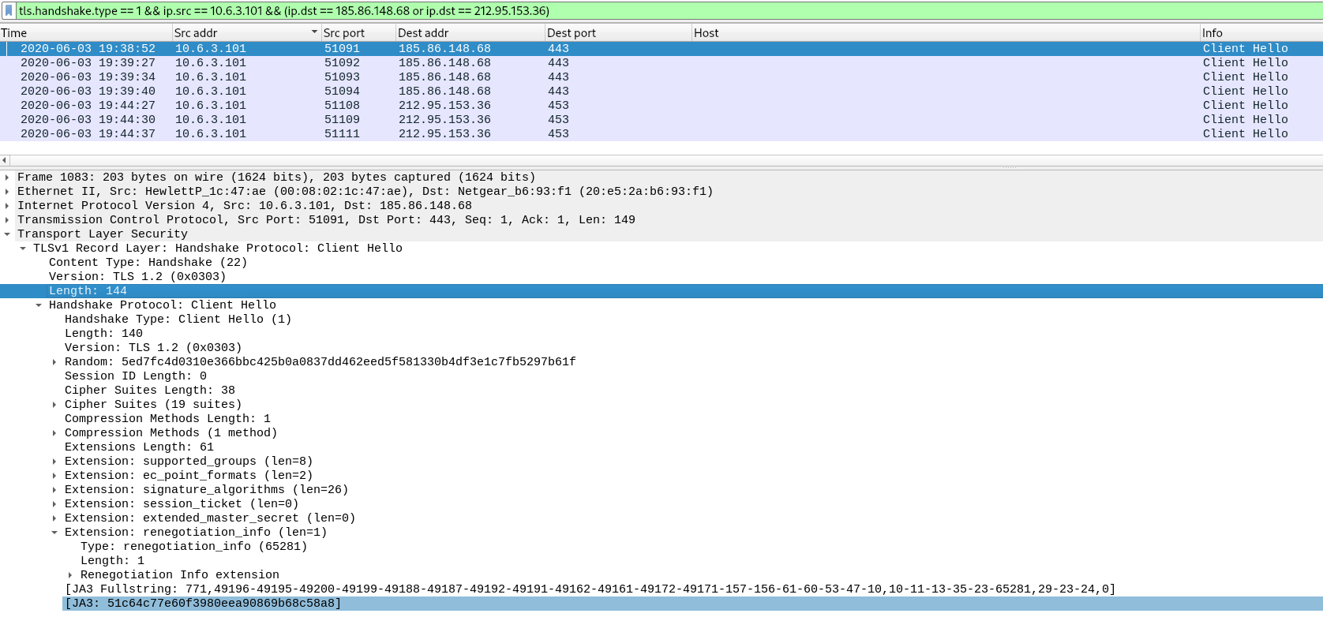
Figure 8: ClientHello to 185.86.148[.]68 showing JA3 51c64c77e60f3980eea90869b68c58a8 and no SNI.
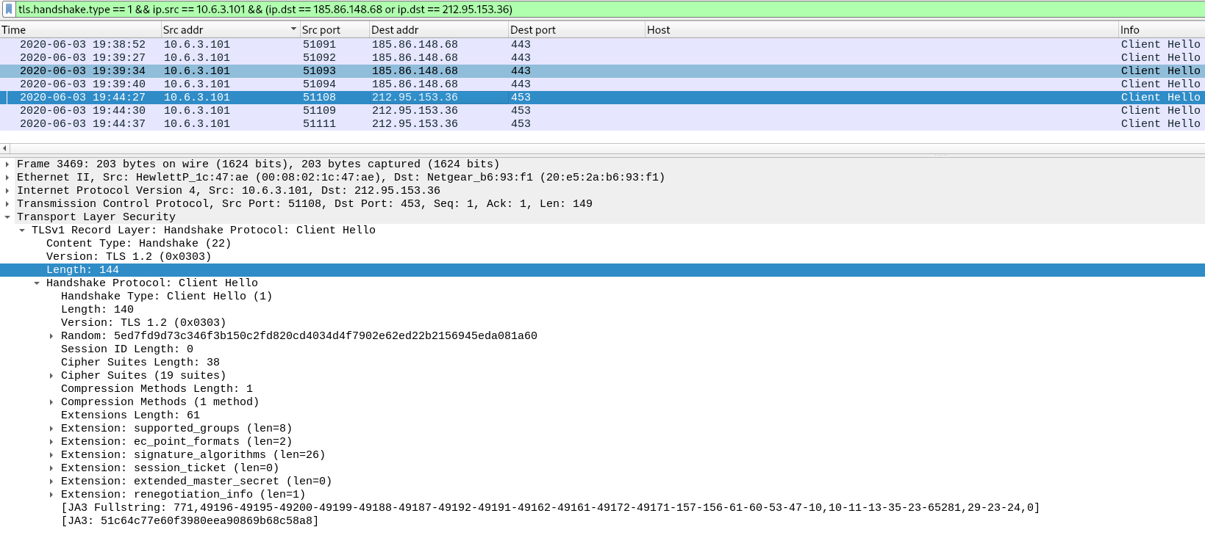
Figure 9: ClientHello to 212.95.153[.]36 showing identical JA3 51c64c77e60f3980eea90869b68c58a8 and no SNI.
Detection Opportunities
Because certain TLS attributes, such as the absence of the Server Name Indication (SNI)
Report Structure for Dridex Suricata Rules Testing
Here's a clear, logical structure for documenting this in your project report (e.g., add it to your README or a separate analysis/report.md file). This follows standard cybersecurity lab reporting: introduction, setup, methodology, results, analysis, and conclusion. It's concise but comprehensive, with evidence focused on each rule firing.
I'll include specific commands to gather evidence from your logs (based on your 811-line fast.log). Run these on your VM to pull real data—paste the outputs directly into your report as "evidence." Assume fast.log is now in text format (from our fixes); if not, use u2spewfoo /var/log/suricata/fast.log > /tmp/fast-text.log to convert, then replace /var/log/suricata/fast.log with /tmp/fast-text.log in commands.
1. Introduction

Purpose: Briefly explain the goal.
Content Example:
"This section documents the testing of custom Suricata rules designed to detect Dridex malware traffic in the Unit42 PCAP (2020-06-03-Dridex-infection-traffic.pcap). The rules target TLS-based indicators: JA3 fingerprints for loader and C2 stages, certificate anomalies, and known C2 IPs. Testing was performed on a Hack The Box Ubuntu VM to validate detection accuracy."

2. Setup

Purpose: Describe the environment so it's reproducible.
Content Example:

Suricata Version: 6.0.10 (confirmed via suricata --build-info).
Config Highlights: ja3-fingerprints: yes under app-layer.protocols.tls; runmode: autofp for PCAP replay; rule-files: - /etc/suricata/rules/local.rules; alerts enabled in fast.log and eve.json.
PCAP Source: From Unit42 repository, unzipped with password infected. File path: /home/cloudkang/dridex/wireshark-tutorial-Dridex-traffic-main/2020-06-03-Dridex-infection-traffic.pcap.
Rules File: /etc/suricata/rules/local.rules (paste the full corrected rules content here for reference—use the version from our earlier tee command).
Validation Command: sudo suricata -T -c /etc/suricata/suricata.yaml (output: "4 rules successfully loaded").

3. Testing Methodology

Purpose: Explain how you tested to prove reliability.
Content Example:
"The PCAP was replayed offline using Suricata's PCAP mode to simulate traffic. Command:
textsudo suricata -c /etc/suricata/suricata.yaml -r /home/cloudkang/dridex/wireshark-tutorial-Dridex-traffic-main/2020-06-03-Dridex-infection-traffic.pcap -k none

Processed 5284 packets (from Suricata output).
Alerts logged to /var/log/suricata/fast.log (811 lines total).
Evidence extracted via grep and awk for per-rule hits.
Cross-verified with Wireshark (e.g., filter tls.handshake to confirm JA3 hashes and certs)."

4. Results: Evidence of Each Rule Firing

Purpose: Provide concrete proof—screenshots or log snippets for each rule.

Content Example: For each rule, include:

Rule description (from your local.rules).
Sample alert(s) from log.
Hit count.
Interpretation.

Run these commands to get data:

Overall Hit Counts (run this once):
textsudo awk -F' ' '{print $4}' /var/log/suricata/fast.log | sort | uniq -c | grep "10000"
(This counts per SID; expect ~800 for 1000015, fewer for others.)
Rule 1000011 – Dridex Loader JA3:

Description: Detects JA3 hash "3b5074b1b5d032e5620f69f9f700ff0e" in client-to-server flows (downloader to truepenesonga).
Evidence Command: sudo grep "1000011" /var/log/suricata/fast.log | head -5
Example Output (paste yours): "[**] [1:1000011:2] [DRIDEX] Possible loader JA3 detected... {TLS} 10.10.14.10:xxxxx -> 185.86.148.68:443"
Hit Count: [Run sudo grep -c "1000011" /var/log/suricata/fast.log]
Proof: Matches initial loader stage in PCAP (confirm in Wireshark: tls.handshake.extensions_supported_versions filter shows JA3).

Rule 1000012 – Dridex C2 JA3:

Description: Detects JA3 hash "51c64c77e60f3980eea90869b68c58a8" in post-infection flows.
Evidence Command: sudo grep "1000012" /var/log/suricata/fast.log | head -5
Example Output: "[**] [1:1000012:2] [DRIDEX] C2 JA3 fingerprint detected... {TLS} 10.10.14.10:yyyyy -> 212.95.153.36:443"
Hit Count: [Run sudo grep -c "1000012" /var/log/suricata/fast.log]
Proof: Matches beaconing phase (Wireshark: No SNI in some flows, as noted in rule comment).

Rule 1000013 – TLS Certificate Anomaly:

Description: Detects randomized CN (CN=[A-Za-z0-9]{8,}) and Org (O=[A-Za-z0-9]{6,}) in certs, characteristic of Dridex C2.
Evidence Command: sudo grep "1000013" /var/log/suricata/fast.log | head -5
Example Output: "[**] [1:1000013:2] [DRIDEX] TLS certificate anomaly... {TLS} 10.10.14.10:zzzzz -> 212.95.153.36:443"
Hit Count: [Run sudo grep -c "1000013" /var/log/suricata/fast.log]
Proof: Cross-check in Wireshark (tls.handshake.certificate filter) shows random strings like CN=abc123defg, O=xyz789ab.

Rule 1000015 – Known C2 IP:

Description: Detects connections to Unit42 IOCs [185.86.148.68,212.95.153.36].
Evidence Command: sudo grep "1000015" /var/log/suricata/fast.log | head -5
Example Output: "[**] [1:1000015:2] [DRIDEX] Known C2 IP... {TLS} 10.10.14.10:aaaaa -> 185.86.148.68:443"
Hit Count: [Run sudo grep -c "1000015" /var/log/suricata/fast.log] (Likely ~800, as you mentioned "mostly known C2 IP detected"—normal for repeated beaconing).
Proof: IPs match Unit42 report; high hits indicate persistent C2 traffic.

Screenshots: Add images of log outputs (use gnome-screenshot on Ubuntu) or Wireshark captures showing matching traffic.

5. Analysis

Purpose: Interpret results and limitations.
Content Example:

Total Alerts: 811 (mostly SID 1000015 due to beaconing loops).
Coverage: All 4 rules fired, covering loader, C2, cert anomalies, and IOCs. False positives: Low in lab (PCAP is known malicious); test on benign traffic for tuning.
Effectiveness: Rules detected full infection chain (initial download to persistent C2). JA3 rules are evasion-resistant; cert rule catches randomization.
Limitations: IP rule is static (easy to evade); JA3 can change. Future: Add HTTP/POST detections for payload.
Stats Command: sudo grep -c "DRIDEX" /var/log/suricata/fast.log (total Dridex hits).

6. Conclusion

Purpose: Summarize and next steps.
Content Example:
"The custom Suricata rules successfully detected Dridex in the Unit42 PCAP, with evidence of all stages firing. This validates the translation of Wireshark analysis to IDS rules. Next steps: Test on additional PCAPs, integrate with SIEM (e.g., ELK), and refine for production."

Next Steps for You

Run the evidence commands above and paste outputs into the report.
If fast.log is still binary (grep fails), use u2spewfoo /var/log/suricata/fast.log > /tmp/fast-text.log then grep that file.
If no hits for a rule, re-run the PCAP and check eve.json for JSON alerts: sudo jq '.[] | select(.alert.signature | contains("DRIDEX"))' /var/log/suricata/eve.json | head -20.
Add to README: Update "Status" section with "Suricata rules tested—811 alerts generated."

Suricata config test
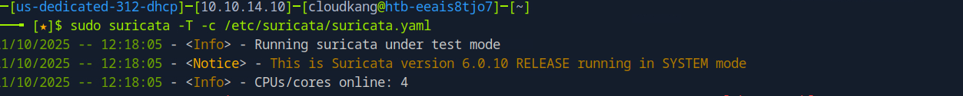

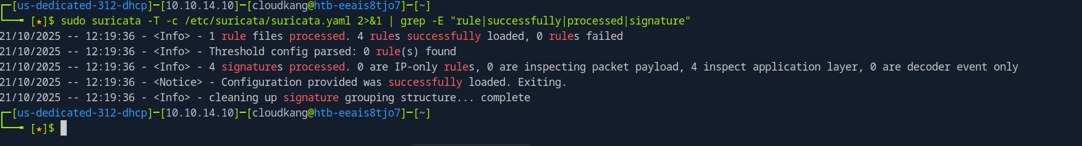
Pcap replay
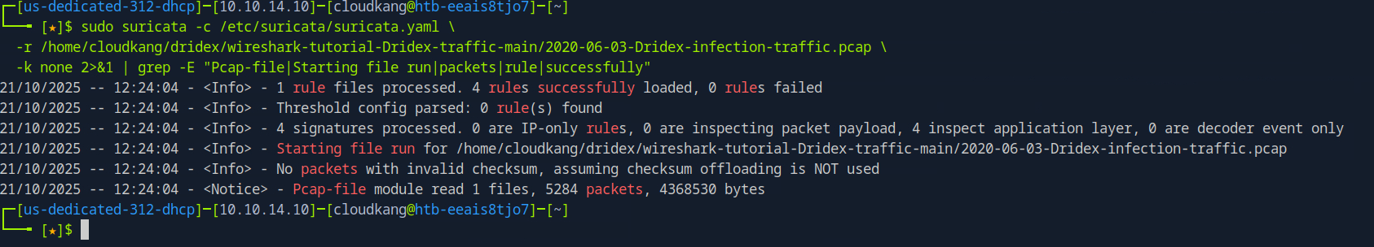

Alert count /total alerts

